**More details for Nonogram Tournament**

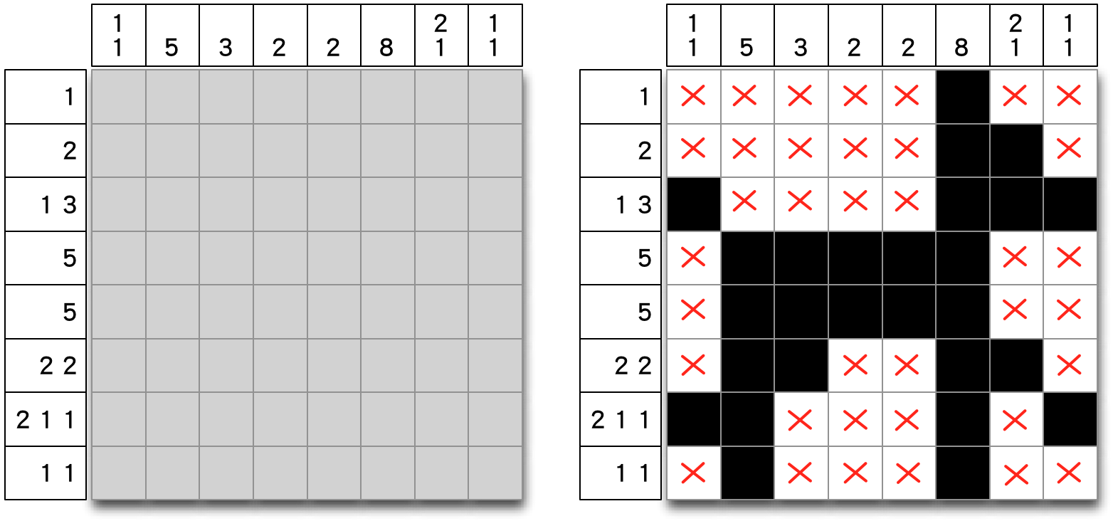

(a) (b)

Figure 1. (a) A Nonogram puzzle designed by Wolter (2012) and (b) its solution.

Nonograms, also known as Hanjie, Paint by Numbers, or Griddlers, are picture [logic puzzles](http://en.wikipedia.org/wiki/Logic_puzzles) on blank grids in which clues are given at the sides of the grid, normally at the left side and upper side, as shown in Figure 1(a). Players are requested to let each cell be either colored black or left blank, such that the sizes of segments of consecutive black cells matches these clues. For example, a row with a clue of "1 3" implies that the row contains two segments with sizes 1 and 3 respectively, in that order with at least one blank among these segments. The grid in Figure 1(b) is the solution of the puzzle in Figure 1(a).

According to Puzzle Museum (2012), a Japanese graphics editor named Non Ishida in 1988 invented Nonograms. In 1990, an UK newspaper *The Sunday Telegraph* started publishing them on weekly basis. Soon, the game is proved to be NP-complete by Ueda and Nagao (1996).

**Tournament Rules**

In this tournament, tournament organizer prepares a Nonogram random generator (Wu, 2011), which is announced to all participants before the tournament, as attached file “boardgen.py”. The generator will produce 1000 25x25 puzzles with a random seed determined by all participants onsite. For example, let the seed be the sum of the numbers given by participants, who do not know the numbers given by others.

The generator generates a grid by painting cells at random. The densities of black cells in these 1000 puzzles will be ranging from 50% to 35% linearly in order. According to Batenburg and Kosters (2009), the most difficult puzzles contain about 20~35% black cells; and the higher density of black cells (more than 35%), the easier the puzzles are. This implies that the generated puzzles (from 50% to 35%) are roughly from easy to hard ones in that order.

Participants provide their executable programs. Then, each program needs to solve these 1000 puzzles in order (without skipping any) on a single-core of a machine within 120 minutes. The machine will be provided by tournament organizer and the specification will be announced after registration deadline.

Clearly, it is not ensured that the puzzles generated by generator have a unique solution. In the case that a puzzle has multiple solutions, programs only need to report one solution.

The winner is the program that solves the most puzzles. In the case that two (or more) programs solve the same numbers of puzzles, then the winner is the program that solves in the less time; otherwise, both tie. Note that, each program needs to record its total time to solve the puzzles.

**Input and Output**

All puzzles are stored in a single file. A symbol “$” is put before each puzzle number. Then the corresponding puzzle starts from the next line. For 25x25 nonogram puzzles, there are 50 lines of clues. The former 25 are clues at the top end from up to down and the later 25 are clues at the left end from left to right.

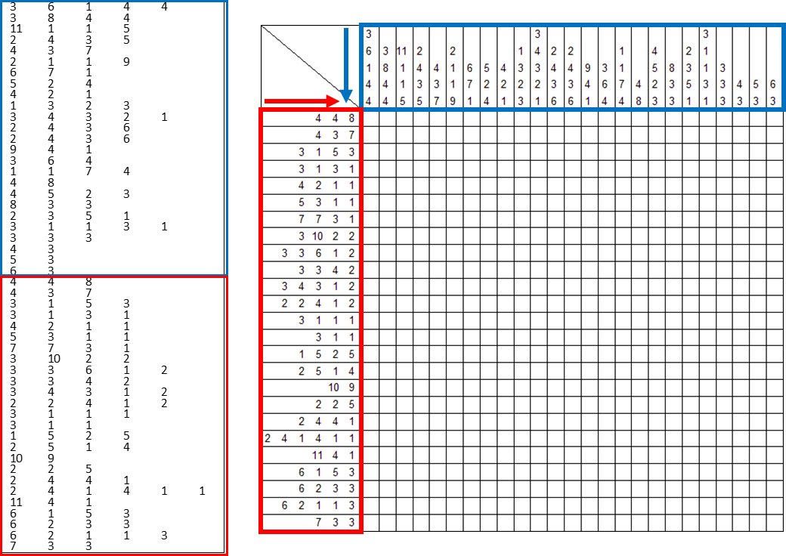

The solutions should be stored into a single file. A symbol “$” should be put before each puzzle number. Then the corresponding solution starts from the next line. Each solution should be stored by 25x25 matrices. A “0” means to leave a cell blank while a “1” means to color a cell black.

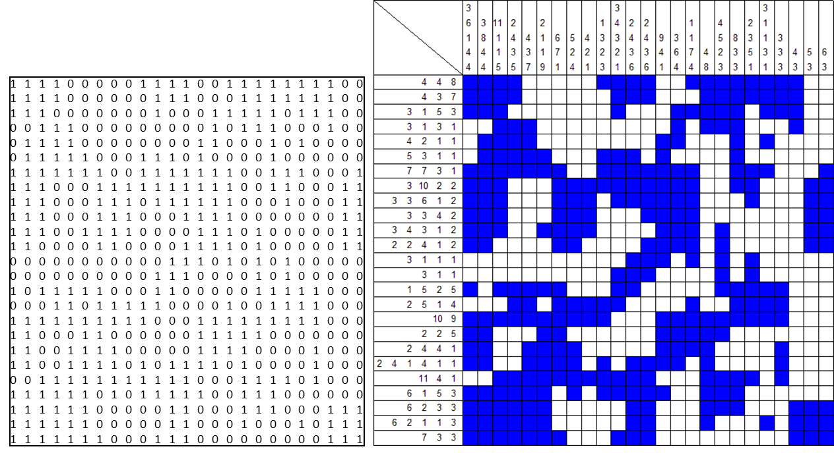

All the numbers in puzzles or solutions are separated by TAB.

The attached files “taai2014-question.txt” and “taai2014-solution.txt” are examples of input and output files respectively.

**References**

Batenburg, K. J., and Kosters, W. A. (2009). Solving Nonograms by combining relaxations. *Pattern Recognition*, Vol. 42, No.8, pp.1672-1683.

Lin, Y.-S., Wu, I.-C., & Yen, S.-J. (2011). TAAI 2011 Computer-Game Tournaments*. ICGA Journal*, Vol. 34, No.4, pp. 248-250.

Puzzle Museum (2012). *http://puzzlemuseum.com/griddler/gridhist.htm*

Wolter, J. (2012). Web Paint-by-Number. *http://webpbn.com*.